Member Benefits

Education
- Free monthly CE
- Free online courses and toolkits
- Reduced fees for Emergency Nursing Conference
- Discounts on certification and recertification
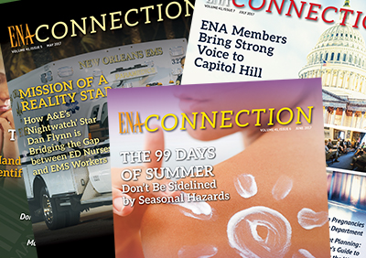

Publications
- ENA Connection
- Journal of Emergency Nursing (JEN)
- ENA STAT Weekly e-newsletter
- ENA Newsline e-newsletter

Get Involved

Local Level
- Serve as a state or chapter leader
- Engage with your state council
- Participate in local events

Member Advantage Discounts
- Discounts from partnered well-recognized businesses
- Liability Insurance with NSO
- Reduced tuition at Chamberlain School of Nursing
- 20% off ENA products and merchandise

Professional Development and Leadership
- ENA Job Center
- Volunteer on a state or national level
- Access to online member community
- ENA Foundation Scholarships and Grants

National Level
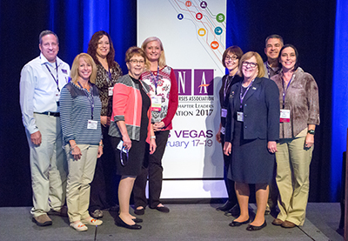
- Apply for Committees, Advisory Councils, and Work Teams
- Volunteer as General Assembly Delegate
- Contribute to JEN or ENA Connection
- Participate in annual conference and webinars
- Nominate your organization and peers for awards
- Honor ENA members who have died
- Share and discuss ideas 24/7 on ENA CONNECT
To join ENA visit www.ena.org Use Referrer Member Number 735491

