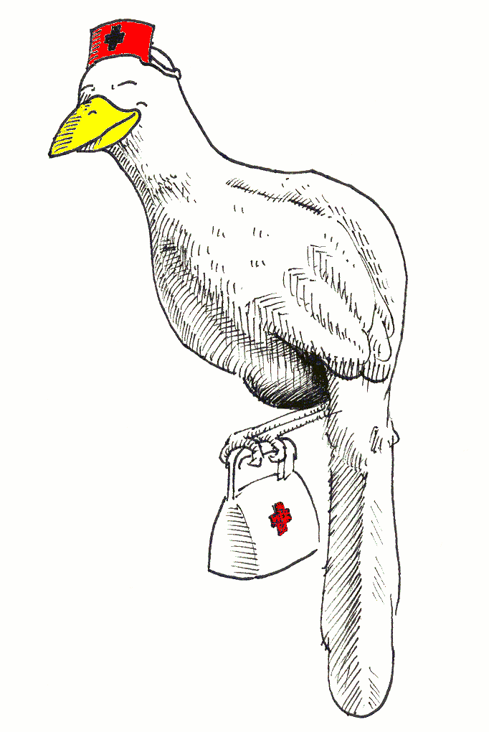
Rio Bravo Chachalacas Election Ballot

Please vote for Chapter 438 RBC officers by midnight “DATE”
Indicate your vote by highlight, X, or underline
Return ballot to: “Name and Email”

President Elect “Year”
Nominee name
Write In___________________________
Secretary “Year”
Nominee name
Write In__________________________
Upper Valley Director “Year”
Nominee Name
Lower Valley Director “Year”
Nominee Name

