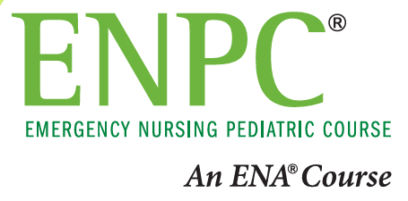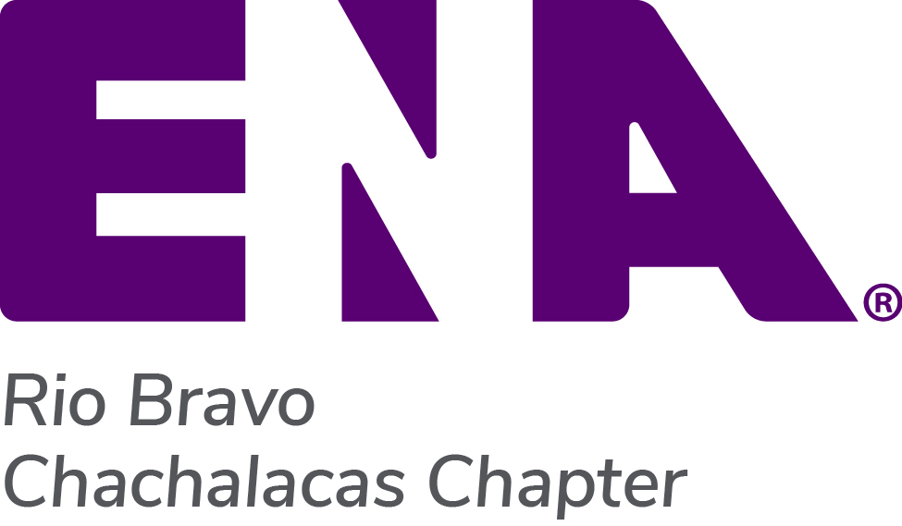
Emergency Nursing
Pediatric Course 6th Edition
Registration Form

Interested in taking the 6th Edition of the Emergency Nursing Pediatric Course? Enhance your ability to care for pediatric patients with innovative online modules supported by a revamped provider manual, preparing you for an interactive classroom experience.

Course Sponsor: ENA Chapter 438 - Rio Bravo Chachalacas

Course Director: Christine Chizek, MEd, BSN, RN, NPD-BC, CCRN, CEN, TCRN, CPEN

Course Times: Day #1: 0800 to 1700 Day #2: 0800 to 1300

Course Fees: $375.00 (includes ENPC 6th Edition Provider Manual)
**Challenger option is available (contact Chris for information and cost)

How to Register: Full payment is due upon registration. There are two ways to register and pay:

- To register and securely pay online via PayPal, visit: riobravochachalacas.com/class-registration

- To pay by check, mail completed registration form below and check payable to ENA Chapter 438 to: ENA Chapter 438, PO Box 1875, Los Fresnos, Texas 78566

Refund Policy: Cancellations received at least 10 days before the class will receive a refund of monies paid minus $90 (printed provider manuals and eBooks are non-returnable and non-refundable). No refunds for cancellations less than 10 days before the live course. No refunds for no shows and/or not completing the course. (Effective 09/09/23) Class dates and locations subject to change.

Please contact Chris Chizek at 956-778-9110 or by email at Rio.Bravo.Chachalacas@gmail.com for more information.

The Emergency Nurses Association is accredited as a provider of nursing continuing professional development by the American Nurses Credentialing Center’s Commission on Accreditation Provider Unit # P0232.

The Emergency Nurses Association is approved by the California Board of Registered Nursing, Provider #2322. This 6th edition ENPC provider course has been approved for 18.25 contact hours.

ADA Statement: In accordance with the ADA, please advise us if you have any disability that requires special materials and/or services so that appropriate personnel can be advised.

Please fill out the information below completely, be sure to select your class and type of manual

Select One | Course Dates | Course Location
☐ | 05/18/24 & 05/19/24 | Knapp Medical Center in the Knapp Conference Center
☐ | 08/24/24 & 08/25/24 | Valley Baptist Medical Center-Harlingen, Woodward Conference Center
☐ | 11/16/24 & 11/17/24 | Valley Baptist Medical Center-Harlingen, Woodward Conference Center

Please select type of manual: ☐ Printed ENPC Manual ☐ eBook ENPC Manual
Name:
Mailing Address:
City / State / Zip:
Email:
Phone #: |  | Hospital Name:

